**AUTOTECH. THE FUTURE OF TRANSPORTATION IS HERE**

*Present the infographic in the below design*

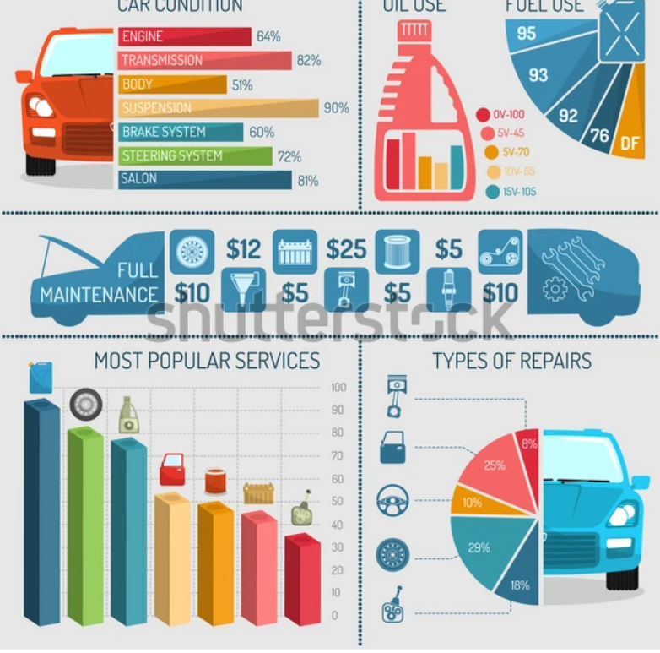

**Automotive Global Revenue Potential by 2030 $ Billion**

*(Present in exact same image as sample half car & half bar chart)*

|  |  |
| --- | --- |
| **Segment** | **Market Size** |
| One-Time Vehicle Sales | 4271 |
| Aftermarket Products & Services | 1288 |
| Recurring Revenues from Mobility Services | 1645 |
| **Total** | **7204** |

**Electrified Vehicles Become Viable & Competitive (000 Units)**

*(Present in exact same image as sample half car & half bar chart (semi handfan chart)*

|  |  |
| --- | --- |
| **Region** | **2022** |
| USA | 882.2 |
| Canada | 146.3 |
| Japan | 80.4 |
| China | 4876.4 |
| Europe | 3197.2 |
| Asia-Pacific | 200.9 |
| Rest of World | 71.1 |

**Essential Facts & Figures**

*(Present in exact same image as sample in between front and rear vehicle image put the number in each box and below text)*

60% of vehicles will become conditionally autonomous by 2030

78% of vehicles will become fully autonomous by 2040

25% to 50% of new-vehicle sales will be electrified vehicles by 2030

78% of vehicle owners exhibit willingness to share their vehicle data with OEMs

$775 billion by 2030 is the potential annual revenue OEMs can earn from monetizing vehicle data

$20 billion by 2030 will be spent by OEMs worldwide on AI technology

2 petabyte of data will be generated by each self-driving car per year

**By 2027, 5G Will Disrupt Connected Car Connectivity Capabilities ($ Billion)**

*(Present in exact same image as sample in bar graph)*

|  |  |
| --- | --- |
| **Connectivity Technology** | **Market Size** |
| 3G | 13.0 |
| 4G | 123.4 |
| 5G | 100.0 |
| **Total** | **236.4** |

**When Cars Begin to Talk. Vehicle-to-Everything (V2X) Market ($ Million)**

*(Present in exact same image as sample half car & half pie chart)*

|  |  |
| --- | --- |
| **Connectivity Type** | **Market Size** |
| Dedicated Short Range Communication (DSRC) | 558.20 |
| Cellular Connectivity | 172.30 |
| **Total** | **730.50** |